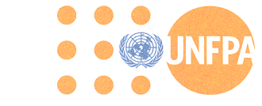
"UNFPA - because everyone counts."

Vacancy Announcement

Position Title: NATIONAL PROJECT PROFESSIONAL PERSONNEL (NPPP) – FGM

Grade: Service Contract (SB-4)

Location: Nairobi, Kenya

Duration: One-year renewable

Closing date: 7 August, 2020

Organizational Unit: United Nations Population Fund (UNFPA)

Reporting to: Chief Executive Officer – Anti-FGM Board

Vacancy announcement Link: https://erecruit.partneragencies.org/psc/UNDPP1HRE/EMPLOYEE/HRMS/c/HRS_HRAM.HRS_CE.GBL?Page=HRS_CE_JOB_DTL&Action=A&JobOpeningId=31814&SiteId=1&PostingSeq=1

